**Use Case Diagram**

**Level:** 0  
**Name:** ISRT Library Management System (LMS)  
**Primary Actor:** User (Student, Teacher, Staff), Librarian, System  
**Secondary Actors:** OTP Generator, Summary Generator, MFS (Mobile Financial Service), Email Generator, Book Purchase Committee (BPC)

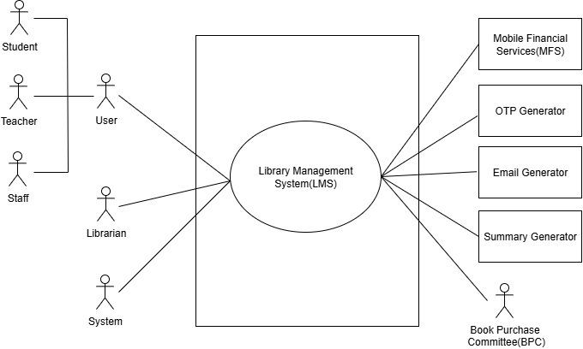

**Figure 1:** ISRT Library Management System (LMS) Use Case Diagram

**Level:** 1  
**Name:** ISRT Library Management System (LMS)  
**Primary Actor:** User (Student, Teacher, Staff), Librarian, System  
**Secondary Actors:** OTP Generator, Summary Generator, MFS (Mobile Financial Service), Email Generator, Book Purchase Committee (BPC)

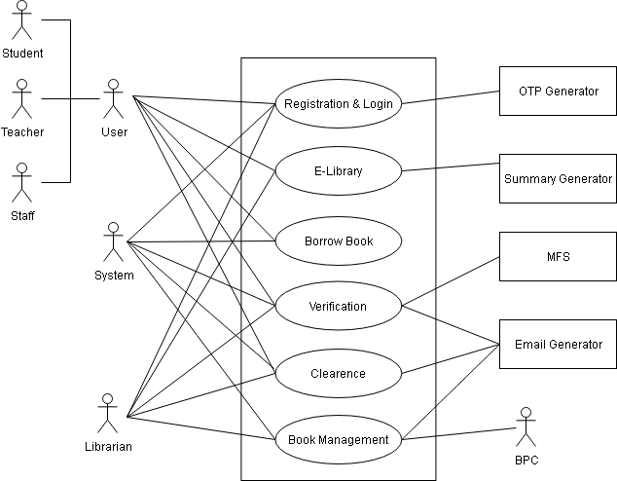

**Figure 2:** ISRT Library Management System (Detailed) Use Case Diagram

**Description:**

1. **Registration and Login:** Manages the creation and secure access of user accounts. Users register by selecting their role (Student, Teacher, or Staff), providing personal and role-specific details, and verifying their identity via OTP. After validation, they create a unique User ID and Password. The subsystem also handles login and password recovery via OTP.

### E-Library: Offers a digital space where book PDFs, research journals, and academic resources are stored and accessible. Users can search for or browse books, download full PDFs, generate summaries, read research publications, and leave reviews and ratings, all while supporting self-paced learning and research engagement.

### Borrow Book: Allows users to request physical books via two methods: manually filling out a form or selecting a book from the catalog. The subsystem forwards requests to the librarian for processing while capturing essential book and user details for tracking.

1. **Verification:** Handles librarian-side operations for borrowing requests. It checks book availability and user eligibility (including unpaid fines, blacklist status, and demerit points) before granting approval. Upon approval, the system generates a confirmation PDF with due dates, fine policy, and an official seal, sending it to the user via email.

### Clearance: Enables users to request clearance certificates when needed (e.g., certificate, marksheet, or pension-related). The system verifies that there are no pending books, fines, or blacklist issues before generating and emailing a PDF clearance certificate. If requirements are not met, a cancellation notice is sent.

### Book Management: Supports the management and growth of the library collection. The system analyzes borrowing trends and user demand to suggest books for purchase. A book purchase committee reviews these suggestions, makes final decisions, and manually verifies bills. The librarian then updates the system’s records to keep the catalog accurate and up to date.

**Level:** 1.1  
**Name:** Registration & Login  
**Primary Actor:** User (Student, Teacher, Staff), Librarian, System  
**Secondary Actors:** OTP Generator, Email Generator

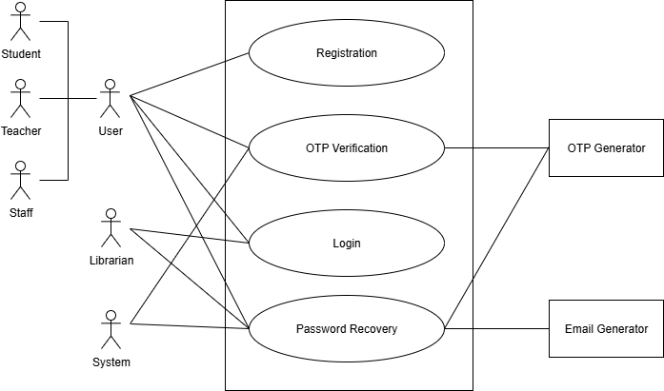

**Figure 3:** Registration & Login Use Case Diagram

**Description:**

1. **Registration:** New users, including students, teachers, and staff, begin by selecting their user type and providing their phone number along with required role-specific details, such as roll number, registration number, session, hall name, institutional email, and address for students, or designation, official email, and address for teachers and staff.
2. **OTP Verification:** An OTP is sent via the OTP Generator to the user’s registered phone number to confirm their identity; this process is used both during initial registration and for password recovery to ensure that only authorized users can access or modify their accounts. Successful verification allows the process to continue.
3. **Login:** After successful registration, users log in using their User ID and password. The system validates credentials and grants access to the role-specific dashboard.
4. **Password Recovery:** If a user forgets their password, they can enter their username and registered phone number to receive an OTP for identity verification. After verifying the OTP, they can set a new password, and the Email Generator sends a confirmation email to ensure account security.

**Level:** 1.2  
**Name:** E-library  
**Primary Actor:** User (Student, Teacher, Staff), Librarian, System  
**Secondary Actor:** Summary Generator

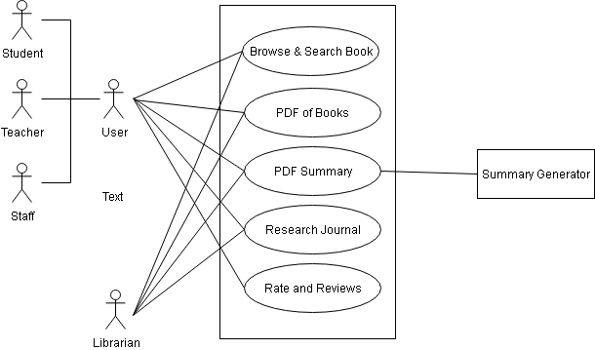

**Figure 4:** E-library Use Case Diagram

**Description:**

1. **Browse & Search Book:** Users and librarians can browse the library catalog or use smart search to find books by title, author, subject, etc., with filtering options.
2. **PDF of Books:** Users and librarians can access and download full digital copies of available books in PDF format from the E-Library.
3. **PDF Summary:** Allows users and librarians to download AI-generated summaries of books. The Summary Generator component powers this process.
4. **Research Journal:** It enables students, teachers, staff, and librarians to access published research journals authored by ISRT faculty and researchers. The librarian is responsible for uploading research journal PDFs to the system, ensuring that new publications are regularly added and made accessible to all authorized users for reading and reference
5. **Rate and Reviews:** Users (students, teachers, staff) can provide star ratings and write reviews on books they’ve read. Librarians may view these for quality assurance.

**Level:** 1.3  
**Name:** Borrow Book  
**Primary Actor:** User (Student, Teacher, Staff), System

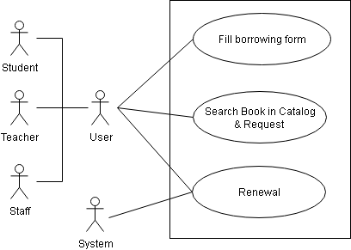

**Figure 5:** Borrow Book Use Case Diagram

**Description:**

1. **Fill Borrowing Form:** Users (students, teachers, staff) can manually fill out a borrowing request form by entering key book details such as title, author, and classification number. Alternatively, if a user selects a book from the catalog, the system auto-fills this form with the relevant data.
2. **Search Book in Catalog & Request:** Users can search for books using the library catalog, including a smart search feature that allows queries by title, author, classification number, or subject through text or voice input. The system also suggests books if the user enters nearly correct or partial information, helping to refine the search. Results can be further filtered for more precise browsing. Once users find a desired book, they can proceed to borrow it directly from its detail page.After completing the borrowing form either manually or via catalog auto-fill, users submit the request for processing. The system forwards the request to the librarian’s admin panel.
3. **Renewal**: Users can request to extend the return deadline of a borrowed book from their dashboard. The request is sent to the librarian for review. If approved, the system updates the due date and sends a new confirmation PDF to the user. Each user may renew a book up to two consecutive times. If no renewal is granted and the due date passes, the system automatically adds a demerit point.

**Level:** 1.4  
**Name:** Verification  
**Primary Actor:**  User (Student, Teacher, Staff), Librarian, System  
**Secondary Actor:** Email Generator, MFS

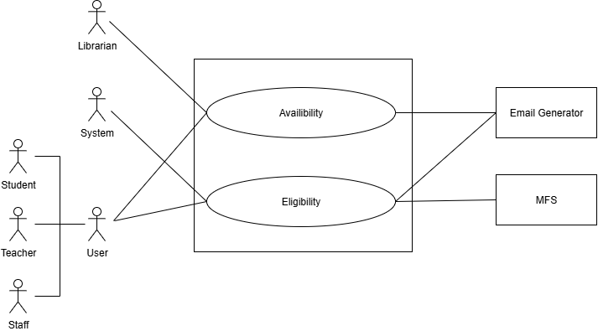

**Figure 6:** **Verification Use Case Diagram**

**Description:**

This use case manages the approval process for book borrowing. After a user submits a borrow request, the librarian initiates checks through the Availability and Eligibility subsystems. If books are available and the user meets all criteria (no fines, not blacklisted), the librarian approves the request and sets a custom return date. A confirmation PDF is generated and sent via email. If the request is denied, a cancellation notice is sent with the reason. Fines and penalties are handled through MFS integration

**Level:** 1.4.1  
**Name:** Availability  
**Primary Actor:** Librarian, System  
**Secondary Actor:** Email Generator

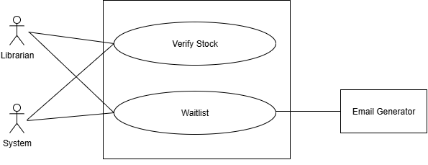

**Figure 7: Availability Use Case Diagram**

**Description:**

This subsystem verifies the real-time stock of requested books. The librarian can check whether copies are available or if the book is already on hold. If unavailable, the system adds the user to a waitlist queue, prioritizing teachers first, then others by request time. The Email Generator notifies users about status updates or waitlist placement.

**Level:** 1.4.2  
**Name:** Eligibility   
**Primary Actor:** User (Student, Teacher, Staff), System  
**Secondary Actor:** Email Generator, MFS

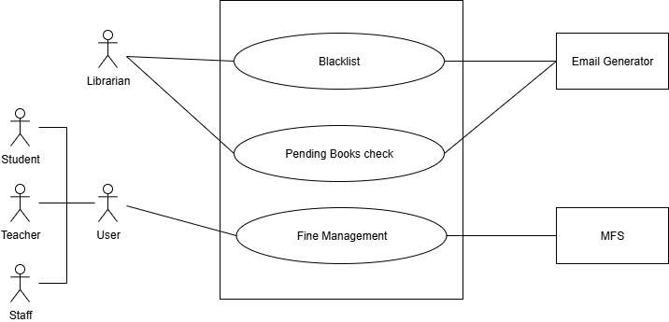

**Figure 8:** **Eligibility Use Case Diagram**

**Description:**

This use case verifies whether a user is eligible to borrow a book. It checks for unpaid fines, demerit points, or blacklist status. If the user fails any of these checks, the request is automatically rejected and a cancellation email is sent. Fine calculations and status updates are handled through MFS. Eligible users proceed to the final approval step.

**Level:** 1.5  
**Name:** Clearance  
**Primary Actor:** User (Student, Teacher, Staff), Librarian, System  
**Secondary Actor:** Email Generator

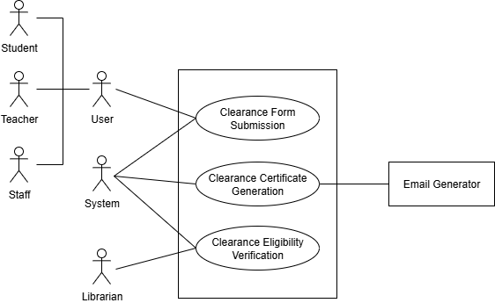

**Figure 9:** Clearance Use Case Diagram

**Description:**

1. **Clearance Form Submission:** Users (students, teachers, staff) submit a role-specific clearance form via their dashboard, providing necessary personal and institutional details. The request is forwarded for verification.
2. **Clearance Eligibility Verification:** The librarian checks if the user has pending books, unpaid fines, or blacklist status. Eligible users proceed; ineligible ones receive a rejection with reasons.
3. **Clearance Certificate Generation:** For eligible users, the system generates a PDF clearance certificate with user details and a library seal. It is emailed to the user via the Email Generator and added to their dashboard.

**Level:** 1.6  
**Name:** Book Management  
**Primary Actor:** Librarian  
**Secondary Actor:** BPC(Book Purchase Committee)

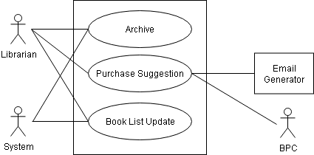

**Figure 10:** Update Book Record Use Case Diagram

**Description:**

1. **Purchase Suggestion:** Matches the data-driven recommendation system that supports the faculty book purchase committee.
2. **Book List Update:** The admin manually adds newly purchased books to the book list, entering all relevant details to make them available for users in the catalog. Similarly, any books that are damaged or no longer usable are deleted from the list to prevent future borrowing requests. This process maintains the reliability and quality of the library’s available resources.
3. **Archive**: Allows librarians to store records of removed or outdated books for internal reference and auditing, without displaying them in the active catalog.